  - Middleware
- Middleware is the layer between the apps or OS, enabling them to communicate and exchange data smoothly.
- Different types of middleware:
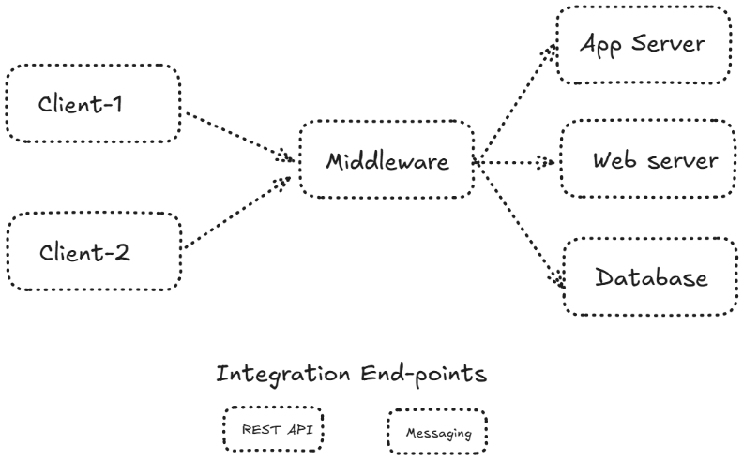
  - Message oriented – it queues the data (messages). Ex: RabbitMQ and Kafka.
  - Object request brokers – remote method calls. Ex: Cobra.
  - Database middleware – connects applications to database. Ex: JDBC & ODBC
  - RPC – invokes functions on a remote system. Ex: gRPC and SOAP.
  - Web middleware – hosts and routes web traffic. Ex: Apache, tomcat, Nginx
  - API gateway – manages and secures API traffic. Ex: Apigee.
- Where middleware helps you in the enterprise systems:
  - It connects various services together (web, db).
  - It allows the integration across hybrid cloud platform.
  - It helps in microservices.

  - Introduction to web services:
- Web services are the standardized way of integrating web-based applications using protocols and data formats like HTTP, XML, JSON, SOAP and REST APIs.
- These web services allow an application to communicate and share data and services among themselves over internet.
- It acts as a bridge between apps or OS or any platform.
Why to use web services?
- Web services provide interoperability – they allow different apps written in different languages and running on different platforms to communicate.
- Benefits of using web services:
  - Language and platform independent.
  - Scalable
  - Firewall friendly (uses the standard ports 80/443)
- Disadvantages:
  - Latency (for remote communication).
  - Security risks, if not properly secured.
Types of web services:
SOAP
- SOAP is a protocol-based web service which uses XML to encode your requests and responses to run over HTTP/HTTPS.
- It’s a protocol with strict standards.
- Platform and language independent.
- It is used within the enterprise-level apps like banking and financial transactions.
REST web services
- REST uses HTTP methods (GET, POST, PUT & so on.)
- It is much light-weight and fast.
- It uses JSON or XML.
- Easily consumed by mobile, web and cloud apps.
- Ex: X.com, Google Maps.
XML-RPC / JSON-RPC
- These protocols use XML/JSON to encode data and send it via HTTP.
- Simpler than SOAP and much more light-weight.
gRPC
- Google Remote procedure call.
- It is modern high-performance RPC developed by Google.
- Useful in Microservices and Kubernetes.
OData Protocol
- Open Data Protocol
- This is REST-based protocol for querying and updating environments.

WebSocket
- It allows the bi-directional TCP connection.
- This is used in real-time web services like chats, IoT.
  - Application server and Integration endpoints:
Application server
- An application server is a software framework that provides enterprise applications to run smoothly, securely and efficiently.
- It acts as a bridge between the front-end client/apps and back-end database.
- We can deploy this is business logic, webservice or middleware components.
- Why to choose application server:
  - Hosting web application or enterprise applications.
  - Managing the session state and resources.
  - For performing load balancing, clustering and failover.
- Examples:
  - Apache tomcat Java-based
  - JBoss Java-based
  - Weblogic Java-based
  - IBM web sphere Java-based
  - Microsoft IIS .NET-based
  - Nginx/Apache
Architecture of application server:
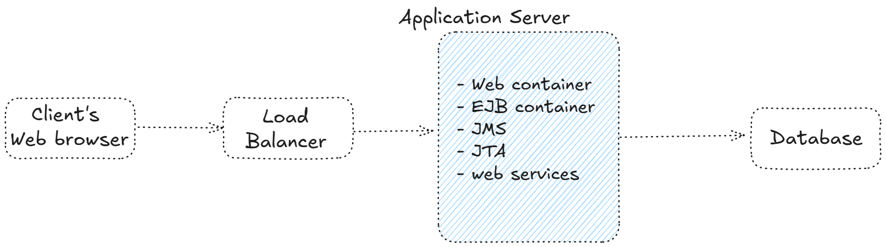

  - Application server and Integration endpoints:
Integration endpoints
- Integration endpoints are the interfaces where exchange of data or services happens.
- Basically, it’s the entry or exit point for communication between systems.
- Types of integration services:
  - Web service endpoint
  - Database endpoint
  - Message queue endpoint
  - FTP endpoint
  - API Gateway endpoint
  - Cloud service endpoint

  - Two-tier and Three-tier architecture
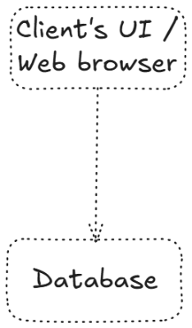
Two-tier architecture
- It is a client-server architecture where the client communicates with backend (database) directly.
- Layers:
  - Client tier UI / Application / browser
  - Database tier MySQL, Microsoft SQL Server, Oracle.
- Simple and faster.
- We use it for the small-scale application due to its easier development and maintenance.

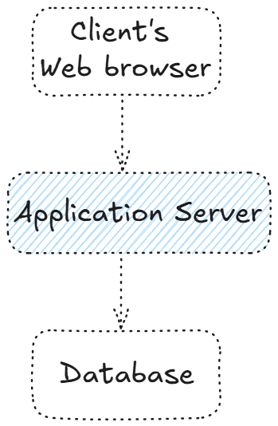
Three-tier (n-tier) architecture
- This architecture separates an application into the presentation, business logic and database layer.
- This makes it more modular and scalable.
- Layers in 3-tier architecture:
  - Presentation tier – frontend (web/mobile)
  - Application tier – middleware or application server
  - Database tier – database server
- Highly scalable
- Better security than 2-tier
- Easy to maintain
- Design is complex / complex design.

  - Install an Application Server
For windows / Linux
- Prerequisites
  - JDK 8 or above must be installed.
  - Sufficient space (disk) and memory (RAM).
  - Must have admin (root / administrator) privileges.
  - Firewall 8080, 8443, 80 & 443.
- Download the server application
  - Tomcat https://tomcat.apache.org/download-90.cgi
  - Web logic https://www.oracle.com/middleware/technologies/weblogic-server-installers-downloads.html
- Configure the environment variables
  - Set JAVA_HOME variable.
- Start the server and access it
  - URL: http://localhost:8080

  - Introduction to Profiles
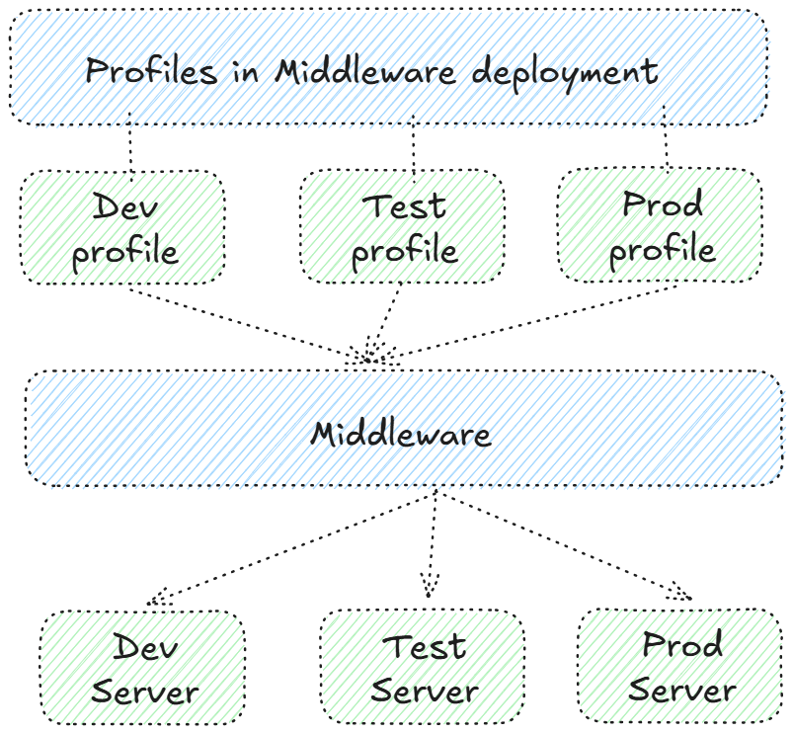
- Profile is commonly used in application servers and integration endpoint platforms.
- In middleware, it refers to a customizable configuration set that determines how a middleware component behaves or runs.
- Behavior like:
  - Startup mode
  - Enables services
  - Memory and JVM settings
  - Security
  - Logs
  - Runtime roles (admin, client)
- Purpose of using profile:
  - Configuration management (CM)
  - Feature isolation
  - Flexible deployment
  - Easy packaging
Examples of Profiles in middleware technologies:
- WebSphere Application Server (WAS)
- Default profile standard server setup.
- Admin profile central domain management
- Application server profile base profile to host application
- Custom profile used for federation nodes
- Tomcat
- Separate configuration folders for different profiles.
- Startup scripts with JAVA_OPTS
- Environment-specific WAR deployments

Federation profiles:
- A federation profile defines how identities, tokens and trust relationship are established and managed across domains.
- A federation profile is a configuration template that includes:
  - IdP (Identity provider)
  - Service provider
  - Protocol
  - Certificates
  - User attributes
- Common federation profiles:
  - SAML web SSO
  - OAuth 2.0
  - WS-Federation
- Tools that use federation profile:
  - Azure AD Microsoft EntraID B2C
  - Okta
  - Auth0
  - PingFederate

  - Installing Apache Tomcat on CentOS 9
Prerequisites
- CentOS 9 Stream or CentOS 9 minimal or any linux OS
- Sudo privileges login with “root” user.
- Internet access
Installing Java
- Tomcat needs Java
- Apache Tomcat requires Java 8 or above.
- You have to install OpenJDK
  - # yum install java-17-openjdk -y
Commands to execute:
- Ping to google.com to check internet connectivity:
# ping google.com

- Install the Java package:
# yum install java-17-openjdk -y //or
# dnf install java-17-openjdk -y
# yum install -y java-17-openjdk-devel java-11-openjdk-devel

- Create a new user (tomcat)
# useradd -r -m -U -d /opt/tomcat -s /bin/false tomcat
-r creating a system user
-m create the home directory of the user.
-U create a user group (tomcat)
-d /opt/tomcat sets home directory
-s /bin/false non-login shell
-tomcat username to be created

- Verify, if user is created
# cat /etc/passwd | grep tomcat

- Change the location to /tmp
# cd /tmp

- Download the Apache tomcat linux package using “wget” command
# wget https://downloads.apache.org/tomcat/tomcat-10/v10.1.43/bin/apache-tomcat-10.1.43.tar.gz

- Extract this ‘gz’ file and move the extracted data (files and folder) to /opt/tomcat
# tar -xzvf apache-tomcat-10.1.43.tar.gz -C /opt/tomcat --strip-components=1

- Change the permissions of newly copied files
# chown -R tomcat: /opt/tomcat

- Make all scripts executable
# sh -c 'chmod +x /opt/tomcat/bin/*.sh'

- Create a systemd service file.
# vim /etc/systemd/system/tomcat.service & paste the below code inside this file
[Unit]
Description=Apache Tomcat Web Application Container
After=network.target

[Service]
Type=forking

User=tomcat
Group=tomcat

Environment="JAVA_HOME=/usr/lib/jvm/java-17-openjdk"
Environment="CATALINA_PID=/opt/tomcat/temp/tomcat.pid"
Environment="CATALINA_HOME=/opt/tomcat"
Environment="CATALINA_BASE=/opt/tomcat"

ExecStart=/opt/tomcat/bin/startup.sh
ExecStop=/opt/tomcat/bin/shutdown.sh

Restart=on-failure

[Install]
WantedBy=multi-user.target
:wq!

- Reload daemon (service) and start Tomcat
# systemctl daemon-reexec
# systemctl daemon-reload
# systemctl enable --now tomcat

- Check the tomcat service status.
# systemctl status tomcat

- If firewall is ON
# sudo firewall-cmd --permanent --add-port=8080/tcp
# sudo firewall-cmd –reload

- Test the Apache tomcat page on the browser.
Go to firefox web browser http://<ip-address>:8080

- Enable Tomcat web management interface Edit a file
# vim /opt/tomcat/conf/tomcat-users.xml
<role rolename="manager-gui"/>
<role rolename="admin-gui"/>
<user username="admin" password="admin123" roles="manager-gui,admin-gui"/>
:wq!

- Allow the remote access by removing/commenting line from the following files.
# vim /opt/tomcat/webapps/manager/META-INF/context.xml
# vim /opt/tomcat/webapps/host-manager/META-INF/context.xml

Comment using <!--
<Valve className="org.apache.catalina.valves.RemoteAddrValve"
allow="127\.\d+\.\d+\.\d+|::1"/>
-->
:wq!

- Now restart the tomcat service
# systemctl restart tomcat
# systemctl status tomcat

- Go to browser, refresh it again.
- Type username as “admin” and password as “admin123”.
- Click on “Server Status” button.

